**MIDDLE EAST TECHNICAL UNIVERSITY**

**DEPARTMENT OF ELECTRICAL & ELECTRONICS ENGINEERING**





**TROY TECH**

**FINAL REPORT**

**Section:** 7

**Studio Coordinator:** Mustafa Mert ANKARALI

**Partners:**

Hasan ÖZKARA - 2031888

Kağan ÖZASLAN - 2031854

Caner POTUR - 2031250

Mustafa Ercan OKATAN - 2031193

Mert KAYIŞ - 2030997

Table of Contents

**1. Introduction 1**

**2. Executive Summary** **2**

**3. Design Description 1**

3.1 Top-down system descriptions2

3.2 Technical Specifications of Video Transfer Subsystem 2

3.3 Technical Specifications of Command Transmission Subsystem 2

3.4 Technical Specifications of Motor Drive Subsystem 2

3.4.1 Motors 2

3.4.2 Holonomic Control 2

3.4.3 DC Motor Drive Movements 2

3.5 Technical Specifications of Shooting Subsystem: 2

3.6 Technical Specifications of Power Supply Subsystem 2

**4. Result and Analyses of Performance Tests4**

4.1 Range performance5

4.2 Speed/stability of robot movements5

4.3 Shooting performance5

4.4 Power consumption5

**5. List of Deliverables 1**

**6. Budget 4**

6.1 Actual Expenditures 5

6.2 Total Cost 5

**7. Conclusion 1**

**APPENDICES4**

APPENDIX A5

APPENDIX B5

1. **Introduction**

Members of our company, Troy Tech are interested in creating new approaches in robotic systems and especially tele-operated robots. Our aim is to pioneer the change in robotics industry. In the project called “*Devices trying to score in each other’s goals*”, we aimed to design and construct a robot that is able to score in opponent robots goal. Simplifying the players role and making the game enjoyable is crucial features of our robot. The robot does not have any self-operated or autonomous motion, an operator will control all the movements on the floor including the shooting of the ball. By producing the robot easily and accurately controllable by an operator (player) at a certain distance wirelessly, we aimed at accomplishing both performance criteria and entertainment purposes of the game.

This project had several challenging ways such as the transfer of the video data and commands wirelessly at least 30 meters in closed area. This indoor range limit was our key concern during the design procedure. Another problem was to build a robust controlled device in a small playfield, and it was expected that it moves smoothly and invariant of time. For the purpose of meeting these requirements and challenges, we also had enhanced many design solutions that are feasible and reliable. These solution approaches were also planned efficient in terms of both budget and time. Because we have always been aware of the fact that the most important cost is ‘time’ in all engineering applications.

In this ‘Final Report’, we explain all the details of our overall system including every technical information. In the previous design steps, there were alternative solutions and plan-B’s. We took the advantage of following these operation principles, research and development steps, but here we include only the current parts of our end-product.

**1.Executive Summary**

Nowadays, robotic solutions for innovative technological products include both teleoperation and autonomous actions. As Troy Tech, we are mainly focusing on the teleoperation side and developing new solutions for wireless operations. Moreover, not only does Troy tech develop electronic systems, but also we integrate them and test the whole system. Integration of different systems sometimes become problematic, but we are trying to predict possible difficulties and gather all the parts together in a compatible way. We especially aim both “financial efficiency” and “reliable operation” in our project and these two are essential concepts for us.

Our ongoing project requires a robot playing hockey in a hexagonal playfield. It is supposed to be controlled from at least 30-meters for indoor usage. Tele-operation will be done by just looking at a screen showing the live broadcast. The video recorded by the camera that is located on the robot will instantly transferred to the controller room.

Our teleoperated robot, Helen-V consists of five main subsystems which are video transmission, command transmission, motor control, shooting mechanism and power supply. We gave priority to solve the problem of transferring the live video data with minimum latency from the robot to the controlling side. After doing some research on this problem, we ordered a 600mw 5.8 GHz transmitter and ROTG02 as a 5.8Ghz FPV receiver with a FPV camera for this part and did some tests and quality controls. At the beginning, our camera unit was integrated with the video-transmitting antenna. Then we replaced it by a transmitter with higher power and externally connected camera. This replacement enhanced the distance that video signal reaches both indoor and outdoor areas. The second sub-system is the command transfer where we used digital data transfer from the controlling side to the robot. This sub-system includes an Arduino uno and an Arduino mega connected to NRF24L01 transceivers. We replaced their antennas with larger basic dipole antennas with higher gain in order to increase the communication range. We uses a playstation 1 joystick and NRF24L01 transmitter connected to Arduino uno to give command to motors and shooting solenoid which is on the HELEN-V. The other part consists of three DC motors and two motor driver. These motors connected to three omni-wheels takes controlling data from the Arduino uno connected to the receiver NRF24L01. The last operational sub-system includes the mechanism to shoot the ball into the opponent’s goal. For this purpose, we prefer using a push and pull solenoid with 34 mm stroke length. We increase the 12V source voltage to 35V by the help of the DC-DC up converter and we give energy to the solenoid through the capacitors. This part is also controlled by the digital signal coming from the command transfer system. Finally, we have a power supply system which consists of a 12V accumulator and two power banks. By the help of the power banks, we get 5V DC to energize the arduino mega and camera and the accumulator is for motors and the solenoids. Additionally we have one more power banks at the controller room.

Although this project has many challenging aspects like the wireless data transfer to 30- meters and shooting mechanism , our group members-built consensus on this project involves much fun and the final product will satisfy our engineering enthusiasm. Actually, as Troy Tech Co. our main concern is to develop and produce a properly operating and cost efficient robot in a short period. Eventually, it is great pleasure for us to see HELEN-V in the playfields at the end of the April 2019.

**3.4 Technical Specifications of Motor Drive Subsystem**

**3.4.1 Motors**

We chose “Namiki 22CL-3501PG” for our motor drive subsystem as shown in Fig.10. Its specifications are given in Table 1.

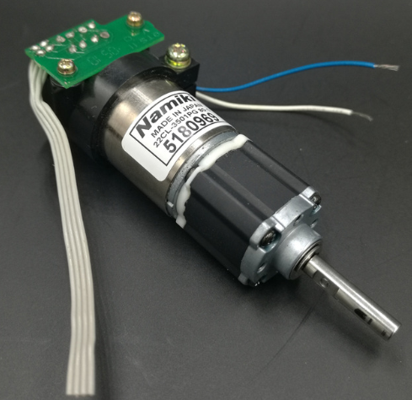

*Figure x. Namiki 22CL-3501PG*

*Table 1. specifications of Namiki 22CL-3501PG*

|  |  |
| --- | --- |
| **Brand** | Namiki Coreless Motor (Japan) |
| **Type** | Gear Motor |
| **Voltage** | 12V |
| **Rated power** | 15W |
| **Stall Torque** | 1.6Nm (16Kg · cm) |
| **Continuous torque** | 0.5Nm |
| **Output speed** | 120 r / min @ 12VDC |
| **Diameter** | 22 mm |
| **Length** | 65 mm |
| **Weight** | 140 g |

**3.4.2 Holonomic Control**

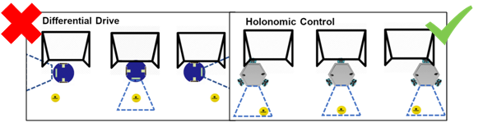We chose holonomic control since its movement is better than the other options. Especially when defending, it is necessary to move left and right parallel to the goal line in order to be able to hold the ball. However, in differential drive method, the robot must turn in that direction in order to go to the right or left. Therefore, he can't see the ball while defending. However, in holonomic control method, the robot can easily go in all directions and defend his goal. The difference between two methods is shown in Fig. x.

*Figure x. The difference between holonomic control and differential drive*

As shown in Fig. x the robot can move multiple directions (i.e. moving forward, backward, left, right and spinning around it). It is based on three separately driven wheels placed on the robot body. The direction of the robot can be changed by varying the relative rate of rotation of its wheels. Therefore, it does not require an additional steering motion. Some example motions with varying speed of wheels are shown in Fig. x.

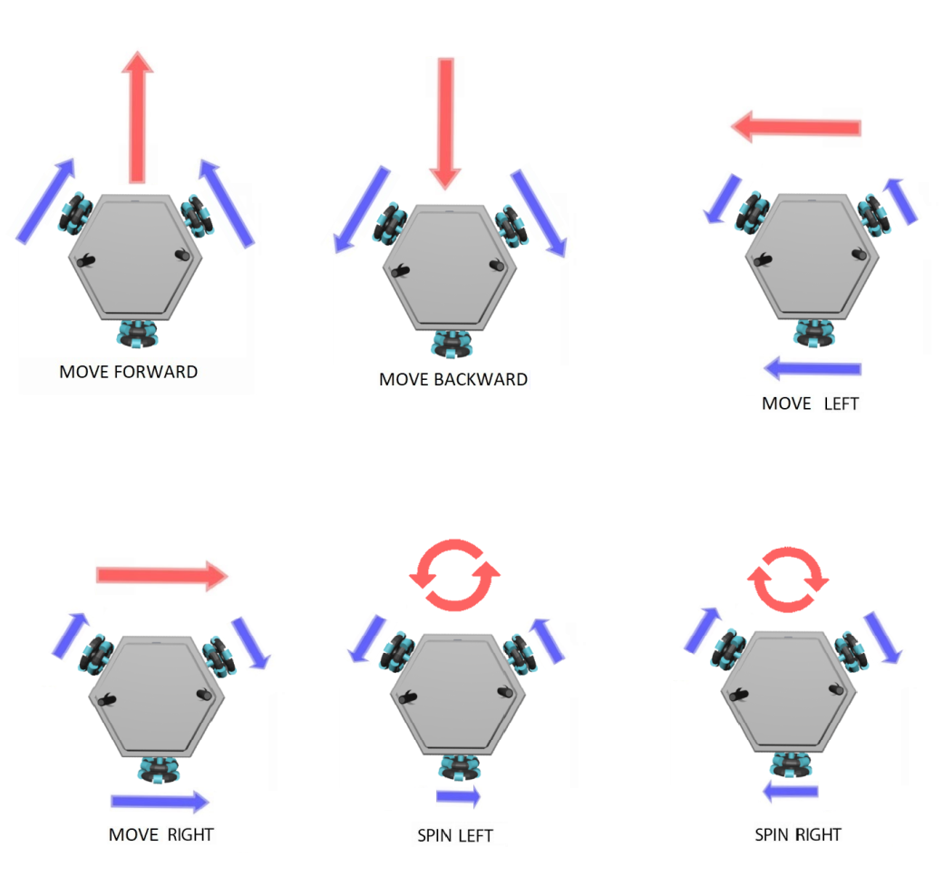

*Figure x. Holonomic drive*

**3.4.3 DC Motor Drive Movements**

**i) Move Forward**

When user moves up the left analog of joystick, robot moves forward. For this operation, the two front DC motors should turn same speed and same rotation. This can be achieved with Arduino by setting the same PWM value to the both front motor pins. Note that different speeds can be obtained by changing the left analog position.

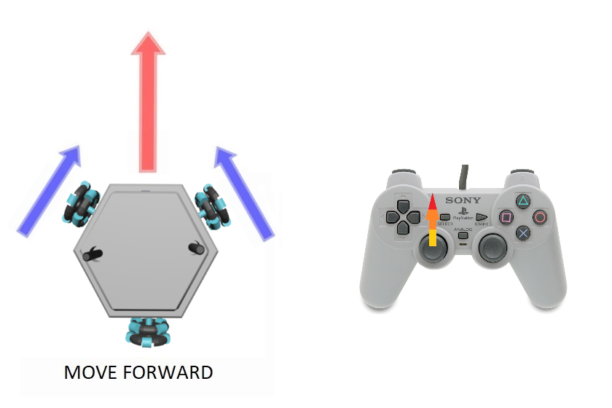

**ii) Move Backward**

When user moves down the left analog of joystick, robot moves backward. For this operation, the two front DC motors should turn same speed and same rotation. This can be achieved with Arduino by setting the same PWM value to the both front motor pins. Note that different speeds can be obtained by changing the left analog position.

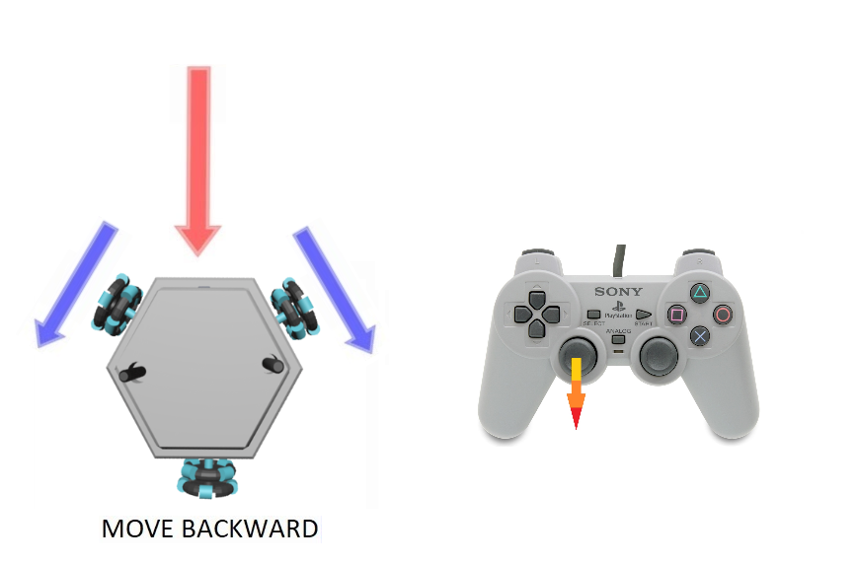

**iii) Spin Right**

When user moves right the right analog of joystick, robot spins right. For this operation, all three DC motors should turn at the same rotation and same speed. Note that different speeds can be obtained by changing the right analog position. This can be achieved by changing the PWM values for the motor pins.

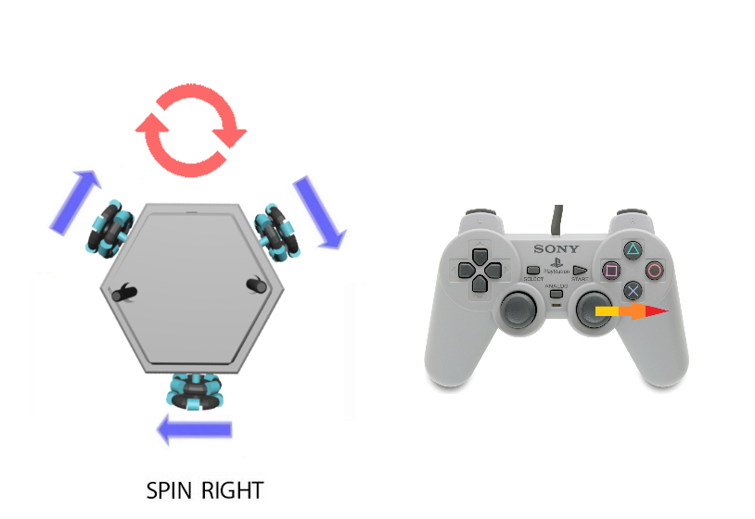

**iv. Spin Left**

When user moves left the right analog of joystick, robot spins left. For this operation, all three DC motors should turn at the same rotation and same speed. Note that different speeds can be obtained by changing the right analog position. This can be achieved by changing the PWM values for the motor pins.

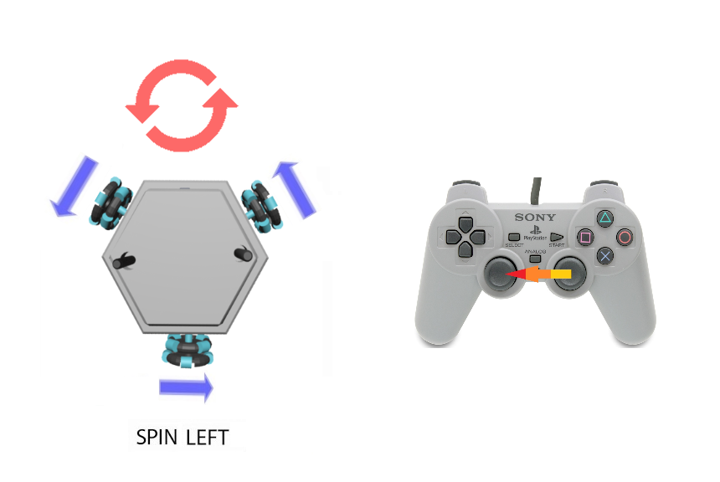

**iv. Move Right**

When user moves right the left analog of joystick, robot move right. For this operation, both front DC motors should rotate CCW direction and bottom DC motor should turn CW direction.

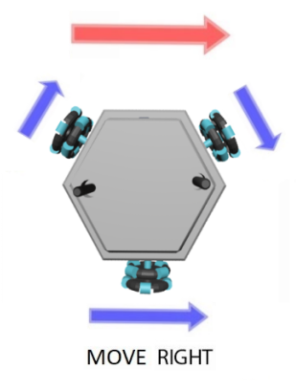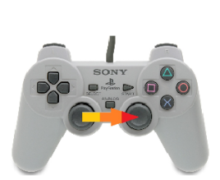

**iv. Move Left**

When user moves left the left analog of joystick, robot move left. For this operation, both front DC motors should rotate CW direction and bottom DC motor should turn CCW direction.

-

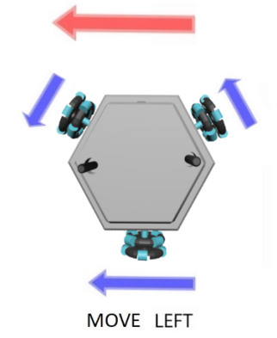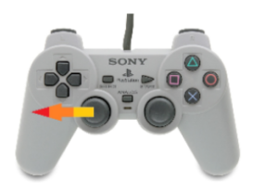

**3.6 Technical Specifications of Power Supply Subsystem**

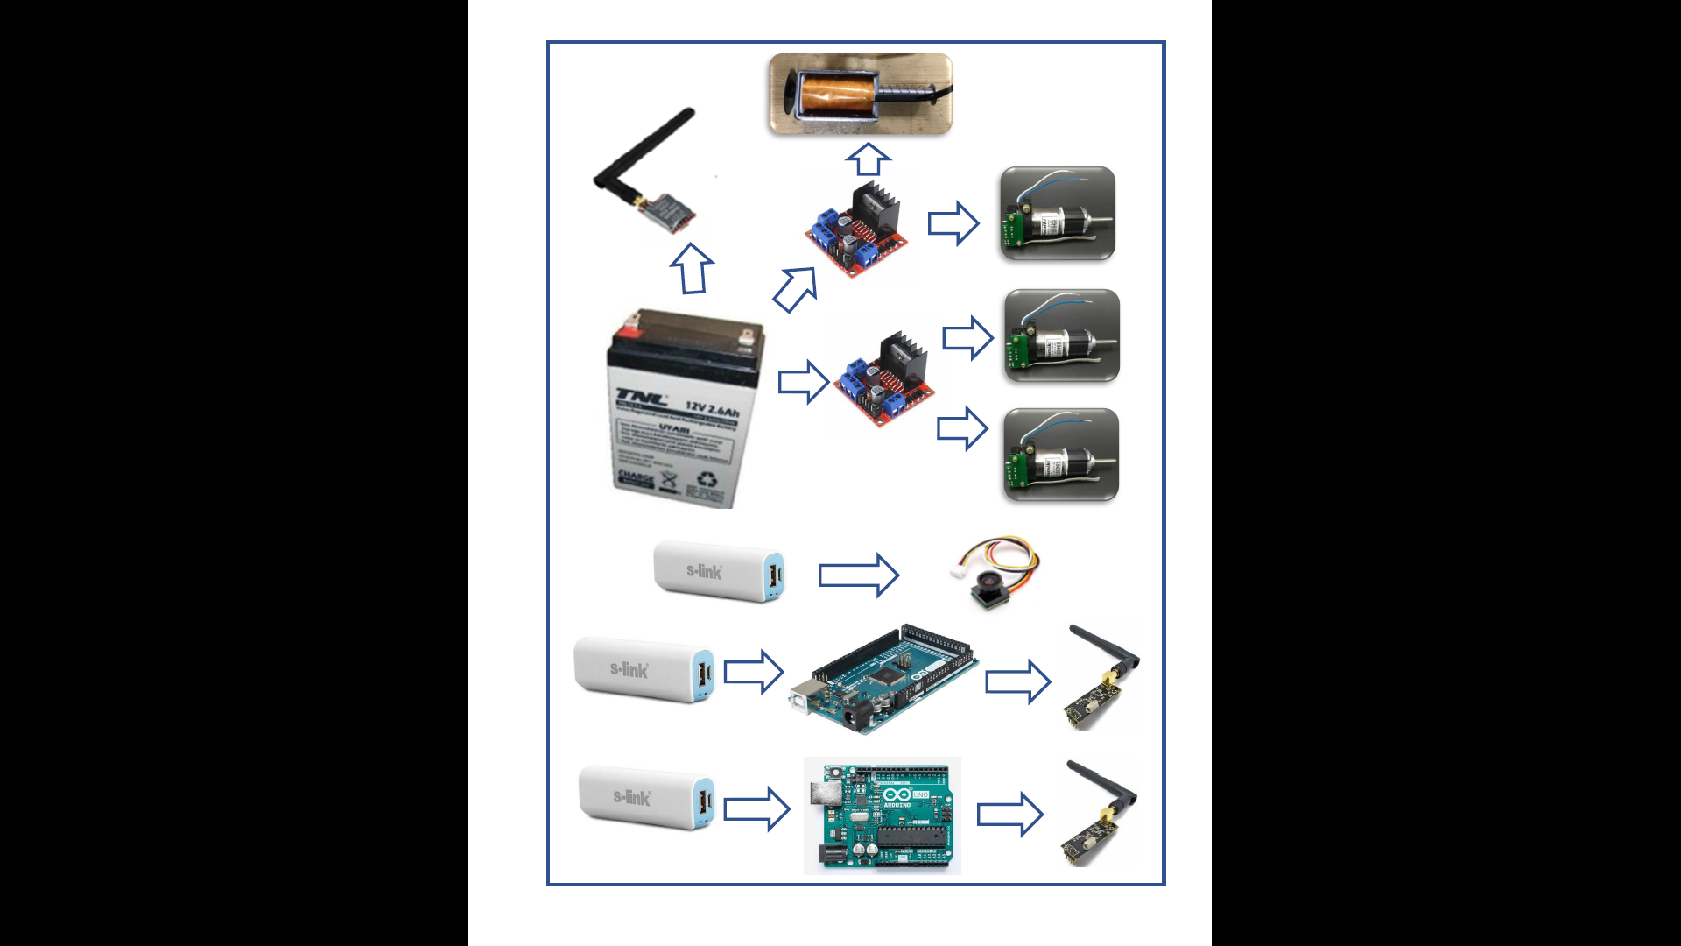

Figure x : Overall power supply subsystem schematic.

For the power supply subsystem, we use one 12V (2.8Ah) accumulator battery with 200 Watts of output power and three power-banks. The reason why we employed accumulator battery instead of a lithium polymer battery is accumulator battery is cheap and easy to charge. Since we did not have any problem with the extra weight coming with this type of battery, it became compatible with the rest of our design.

**7. Conclusion**

Troy Tech delivers a properly designed product which is compatible with the requirements, within a limited timeframe and economic budget constraints. Our main desire as a company is to provide unique and affordable products with significant functions, durability and performance. In this project, we present a perfectly working robot including unique design marks and precious engineering labor.

The product of our company “Helen V” is designed for a specific project which is briefly described as “designing and constructing one of the two teleoperated robots trying to shoot and score in opponent’s goal”. In this ‘Final Report’, we have explained the final steps of our design journey.

As we mentioned in previous reports, we know our responsibilities and requirements for the design procedure. We made enough progress in the first semester. In the second semester we finalized our product by choosing proper components and required improvements. We built our shooting system and modified movement system after lots of researches and comparisons between different alternatives. We tried to implement the most efficient components to our products. Also, we improved our already-working video transmission system and aimed to obtain one beyond the requirements. In addition, we focused on appearance of our “Helen V”. We did our best while designing our product and locating the components to create an eye-pleasing appearance. Neatness was important in terms of both compact sizes and robust character of the robot.

**Appendix A-User Manual**



USER MANUAL

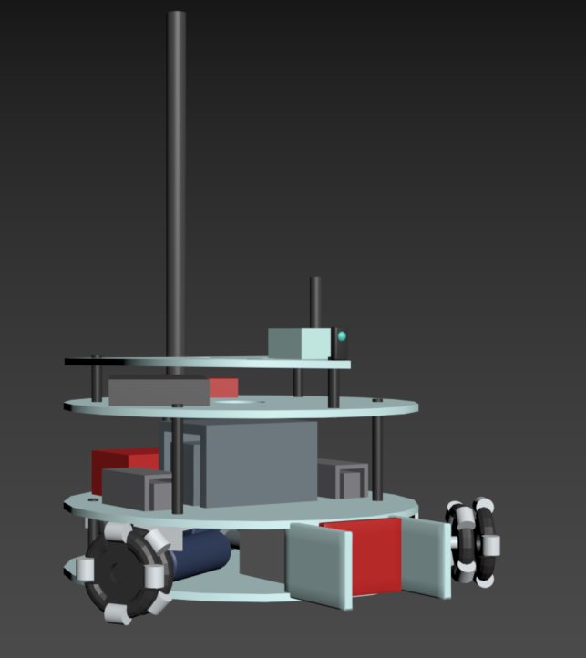

HELEN-V

*May 10, 2019*

Table of Contents

1. What’s inside the box 1

2. Quick Start Guide 2

3. Controls 3

4. Charging 4

5. Care and Maintenance 5

1. **What’s inside the box**

Your shipping box contains Helen-V (Fig. 1), Eachine ROTG02 FPV Receiver (Fig. 2), a command transmitter module with PS1 joystick (Fig. 3), Artengo beach volley ball (Fig. 4) and charging cables. Remove all items carefully and do not discard your shipping box.

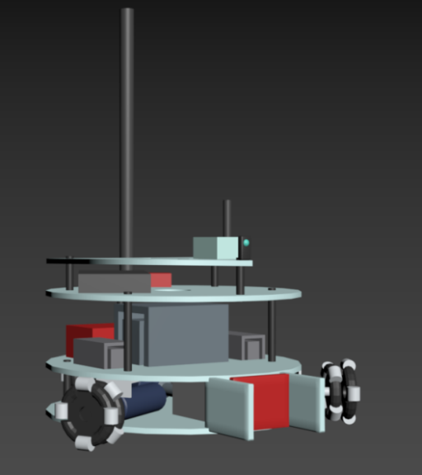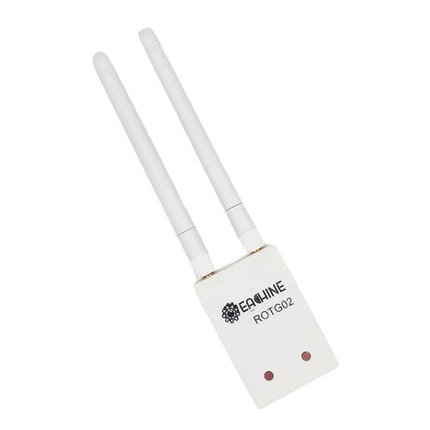

Figure 1. HELEN-V

Figure 2. Eachine ROTG02 FPV Receiver

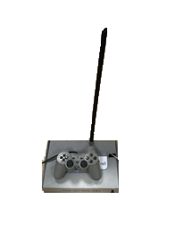



*Figure 4 . Artengo beach volley ball*

*Figure 3. Command Transmitter Module*

1. **Quick Start Guide**

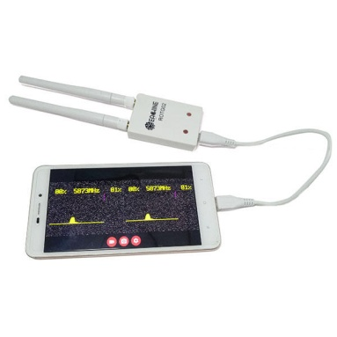

**1**



**2**

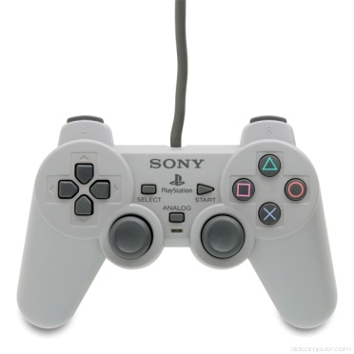



**5**

**3**

**4**

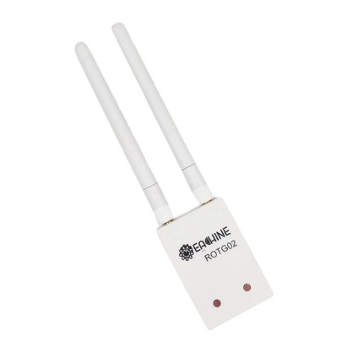



**5.8 GHz**

1. Install any FPV receiver app to your smartphone /tablet/PC (“GoFPV” is recommended.).
2. Connect “ROTG02 FPV Receiver” to your smartphone /tablet/PC..
3. Turn on HELEN-V and command transmission unit
4. Adjust the channel of “ROTG02 FPV Receiver” by pressing the adjust buttons. If you press any of these buttons 2 seconds, it will automatically set the channel.
5. You can start playing the game!
6. 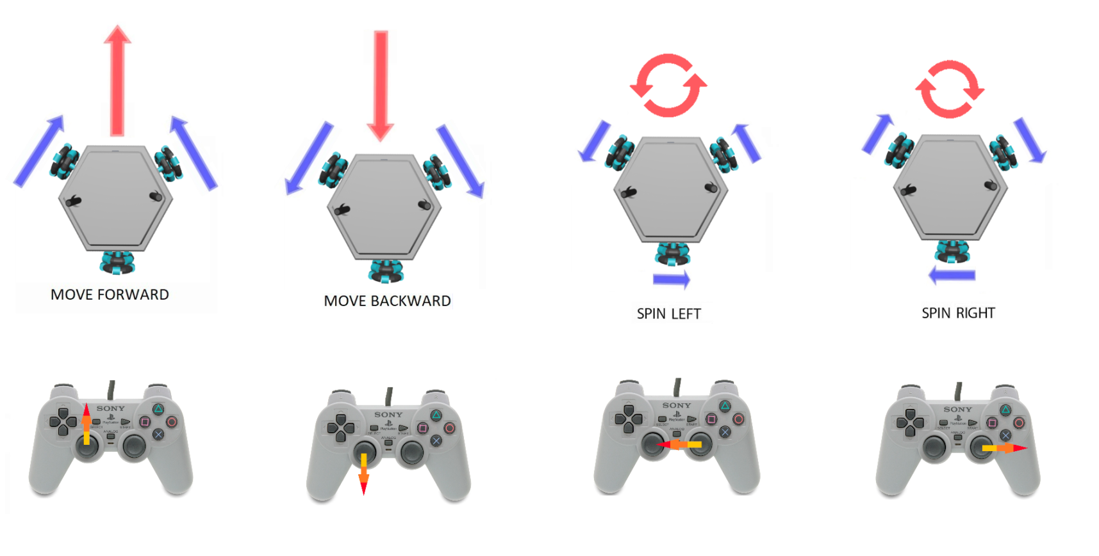**Controls**

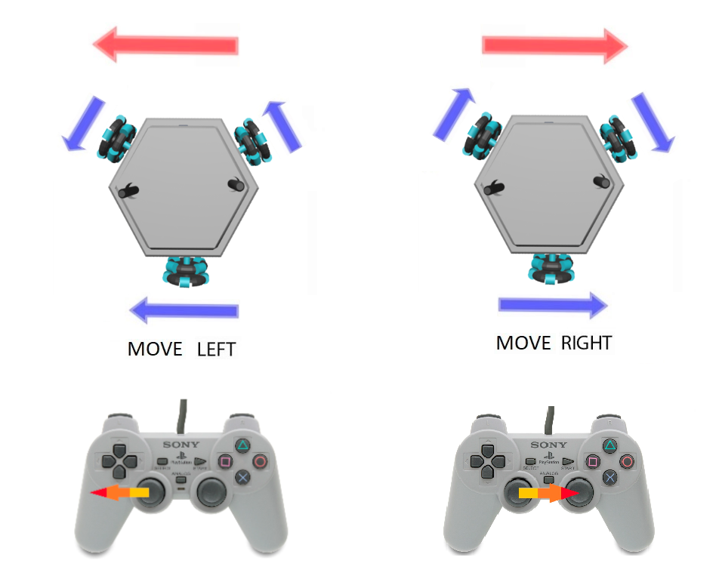

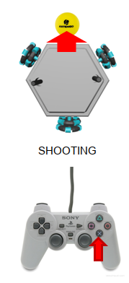

1. 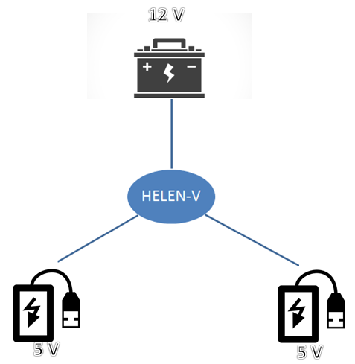**Charging**

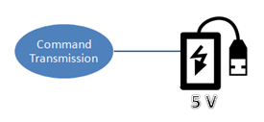

Helen-V includes 2 power-banks and a 12V (2.8Ah) accumulator battery. Moreover, command transmission system has a power bank. You can charge the power-banks with a simple micro-usb cable. You can charge 12V battery using DC supply or a 12 V battery charging adaptor.

**WARNING:**

- While charging the 12 V accumulator battery, make sure that other power-banks are switched off.

- Reverse charging is prohibited! Do not reverse the positive (+) and negative (-) terminals when charging the 12V accumulator battery.



1. **Care and Maintenance**

🡪Recharge the batteries after each use. Only an adult can handle the battery. Recharge the battery at least once a month when the robot is not being used.

🡪Store the robot where the temperature is between -20º and 45º C (-4º to 113º F). Don’t leave it in your car, because temperatures in parked cars can exceed this range.

🡪It does not have a waterproof function, so keep the robot out of water.

🡪Do not use the robot in loose dirt, sand or fine gravel which could damage moving parts, motors or the electric system.

🡪 When not using, all the electrical source should be turn off.

🡪In case of a technical problem, please contact Troy Tech, please do not try to fix the problem by yourself

**Appendix B**